|  |  |  |
| --- | --- | --- |
| **Assignment # 3** | | |
| Course Title | Digital Image Processing | Due Date: 29/11/2021 |

* Reference all the resources you used including my code, in the assignment in the first cell in python
* Every student must do his/her own assignment individually.
* Zero tolerance for plagiarism.
* All code must be properly commented. Code without comments is not acceptable. I am expecting detailed comments on each line of code so that a naive reader even should understand the code logic from your comments.

**Original code must be provided. You must prepare one file containing all the code and write the name of the zip in following format**

**StudentID_Name_Batch**

1. Consider image shown in (a)

* Find the center of the circles and find the distance between centers and display them like shown below in (b).
* Find the angle and display it as shown in (c)

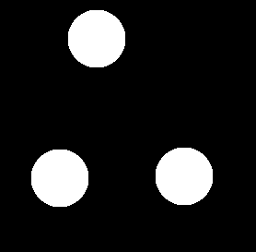 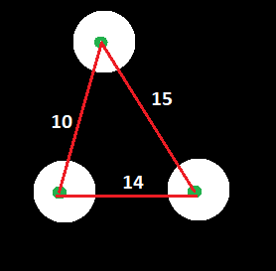 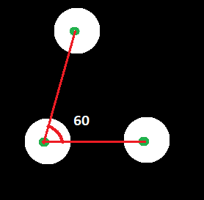

(a) (b) (c)

1. Find that wave with highest number of frequencies (peaks) form the image shown in (a) and then draw bounding rectangle around it as shown in (b).

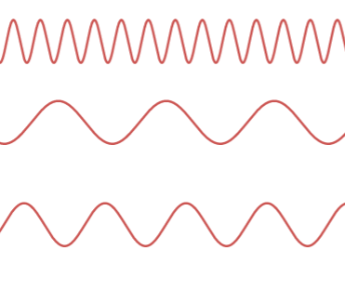 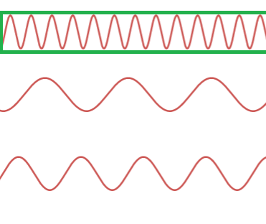

1. (b)
2. Find the location of the zebra crossing and draw a bounding rectangle as shown. Also count the white strips in the zebra crossing and display them.

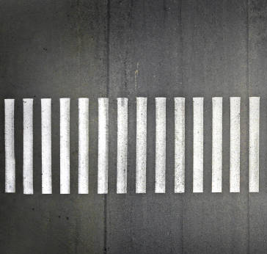

1. An animation video has been provided. In the video you will see a fixe circle (in green) and another circle in blue color. The blue colored circle moves from top in downward direction. You need to display each frame and pause the video where the center of large circle and small circle exactly overlaps (or very close to each other). If the centers of both circles do not overlap, then just keep playing the video till the end.

